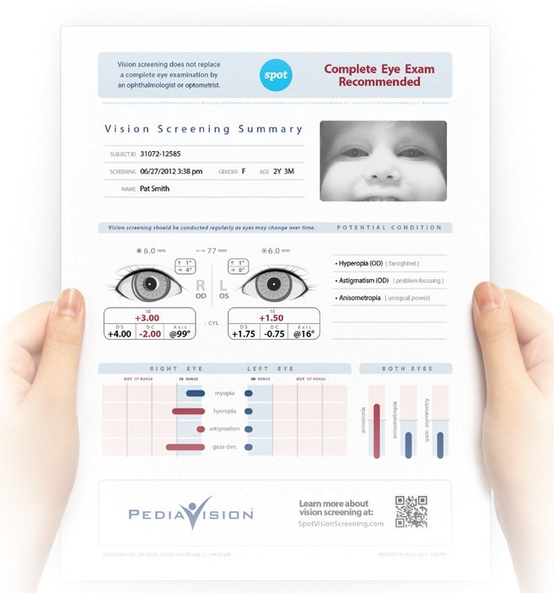

Parents are provided a printout of screening results if a complete eye exam is recommended.

“If we can save the sight of just one child, it is worth it”

For more information about the
CT Lions KidSight Program
Becoming a Lion, or to schedule a
Free vision screening,
Please contact:

Joyce Wruck
Email lionjoyce@comcast.net
Tel: 203 608 8300
Cell: 203 213-1508

Designed by CC Linda Bradshaw
Revised Jan. 2016

The Connecticut Lions
Eye Research Foundation
www.clerf.org

Lions Clubs International
www.lionsclub.org

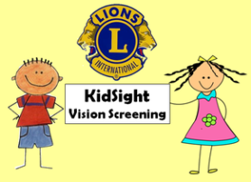

“If you could save a Childs sight with the push of a button, wouldn’t you?”

Connecticut
Lions
KidSight
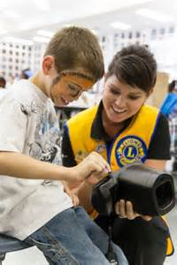
Program

Pediatric Vision Screening
FREE
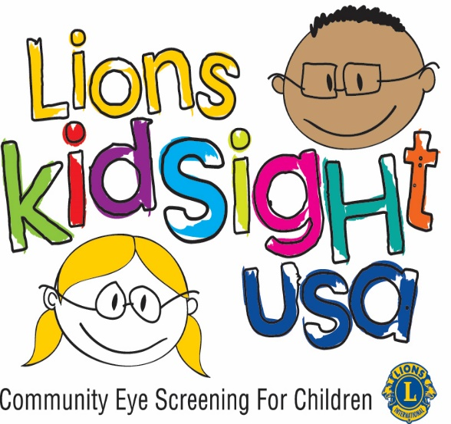
What is KidSight?

KidSight is part of a nationwide initiative of Lions Clubs International to help parent, child care providers and educators to find and treat children’s vision problems

Our Mission is to Address America’s #1 Health Issue for Children –
VISION PROBLEMS

Connecticut Lions KidSight program is funded by the Connecticut Lions Eye Research Foundation (CLERF) under their Lions Eye Health Program (LEHP)

Lions District 23C covers 54 Lions clubs with HIPPA compliant protocols and trained Lion volunteers, dedicated to solving the critical issue of vision problems in children.
Lions offer this service
Free

Our #1 priority is to screen children in the 6 month to 6-year-old age group, since the earlier vision disorders are detected, the higher success rate of correction.

Since children of all ages benefit from vision screening, Lions KidSight will expand its services through Grade School upon a School District’s request.

Why Vision Screening?

The first few years of a child’s life are critical in the development of good vision. Starting as early as 6 months of age, children should have their vision checked.

According to educational experts, 80% of learning is visual. So if a child can’t see well, he can’t learn well. Yet most young children don’t get their vision screened until they have problems learning or paying attention in school. By then, it may already be too late. Unless vision problems are detected early and corrected, they risk becoming permanent by age 7.
The Lions KidSight program assures children are “vision ready” for life and learning, utilizing the latest vision screening technology, the WelchAllyn Spot.

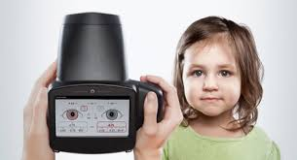

As fast and easy as taking a picture, the WelchAllyn Spot auto-photo refraction device detects vision issues across all age groups – from toddlers to teenagers.

Spot Screens for These
Common Vision Issues

* Risk factors for Amblyopia (lazy eye)
* Strabismus (eye misalignment)
* Myopia (near-sightedness)
* Hyperopia (farsightedness)
* Astigmatism (blurred vision)
* Anisometropia (unequal refractive power)
* Anisocoria: (Unequal pupil size)

Spot Provides Immediate and Meaningful Results

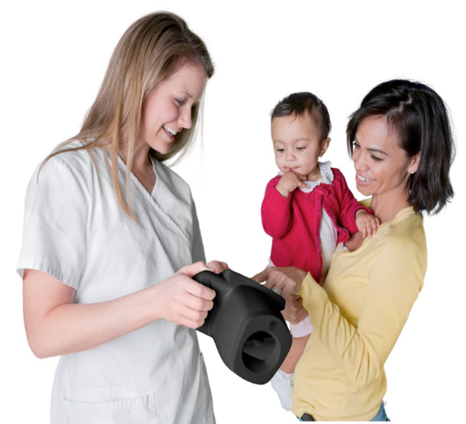

On-screen results are available in seconds.
Results are displayed as either:
All measurements in Range
Complete Eye Exam Recommended
12% of screenings locally have been found to need referral.

