Parent Testimony Letter – Colton Age 17 Months

The opportunity for my son, Colton (17 months at the time) to have his vision screened at such a young age has been life changing. The screening done by the Plainfield Lion’s Club in March 2016, through the FRC playgroup in Plainfield, made a huge difference in our lives. At such a young age the “standard procedure” is to have a pediatrician check a child’s eyes and vision with a series of rudimentary exams during a ‘well baby’ check- up visit. If there are no physical abnormalities noted during these visits it is “standard procedure” to wait until a child is either of preschool or kindergarten age (insurance doesn’t cover eye exams until age 3), to have their vision checked by an eye doctor. Having a family history of significant vision issues, I asked my pediatrician numerous times to have my son’s vision checked, as a proactive measure. I was repetitively rebuffed. I often explained that my vision issue (lazy eye) was caught too late (not until I was 6 and no longer able to be altered) and I did not want my son to suffer a lifetime of issues, that I have had to deal with as a result of this vision abnormality. I often brought up the issue of frequent falling and developmental delays. Having his hearing checked (normal) and the support of Birth to Three for developmental delays; I continued to bring up the issue of concern over Colton’s vision. It was not until I had the vision screening done by the Lion’s Club, that I had solid evidence that Colton needed to see a pediatric ophthalmologist. His screening identified some issues and using that paperwork we were able to convince his pediatrician to give him a referral for an exam. The eye doctor did determine he does have some serious vision issues: blurry vision and astigmatism in both eyes, nearsightedness and the ability to develop a lazy eye, if corrective lenses are not worn. The expense of the glasses (300$), were not covered by my insurance company (as most insurance companies decline to pay this fee); but my husband and I felt that the expense was well worth the future we were hoping to create. I am so grateful to have had the opportunity to get my son some much needed help and the support of numerous people who have made this happen.

Thank you, Erika

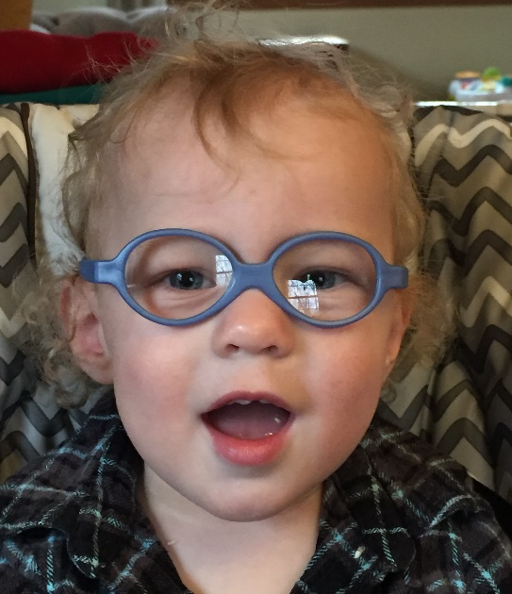
Parent Testimony – Gavin Age 3

In February of 2016, the Lions Club came to our Elementary School to perform a routine eye screening for all students, including my 3-year-old son, Gavin. In this screening, the test found a problem in Gavin’s left eye. Following up on this screening, I took Gavin to a pediatric ophthalmologist in Glastonbury revealing serious problems with his eye immediately resulting in glasses. Gavin has far sightedness, slight astigmatism and his left eye wanders and he may need a patch in the near future. Without this screening, we would have discovered these problems much later, causing further damage to his eye and the nerve connection to his brain. The ophthalmologist also said, had we waited, Gavin could have possibly been legally blind in his left eye. We were completely shocked and scared.
We are incredibly grateful to the Lions Club for providing this service which has truly changed our lives. Our son’s vision is in the process of being repaired and decreasing the progressive damage he would have had I not brought him to the ophthalmologist at such a young age. Saving Gavin’s eye sight was a direct result of a simple screening. We feel truly blessed.
Thank you so very much,
Amanda
