CONNECTICUT LIONS EYE RESEARCH FOUNDATION

LIONS EYE HEALTH PROGRAM PEDIATRIC EYE SCREENING PROGRAM

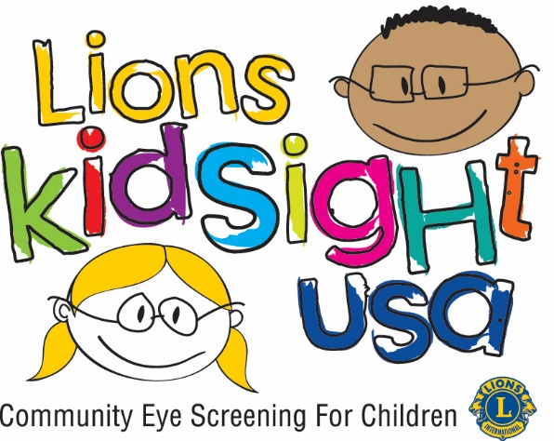

The Simple Process

Lions District 23C

Cabinet Chairs John and Linda Bradshaw

23C KidSight Program: STEP BY STEP

This is a simple step by step overview of how your club could perform a Pre School Eye Screening in your community. It only takes 2-3 volunteers, here are a few tips:

- Gather a team of volunteers available during the day, who are willing and enthusiastic. Ideally, they should be patient with young children and confident enough with keyboard /texting. Background checks are a requirement for most school Districts
- Visit Daycares facilities and Kindergartens to promote the program. Offering this free eye screening to all children between the ages of 6 months -7 years. (Open to Grade School children upon request) A personal visit and follow-up works best but there is a letter (see sample) that can be sent. If they agree the Memorandum of Understanding should be signed and copies of the Parental Consent forms left for distribution, (not necessary in grade school) Agree a provisional date.
- Contact District coordinator to verify availability of the equipment, and arrange training for volunteers, if required.
- Go back to the facilities and firm up the dates and times, check the room available for screenings to be sure it is suitable.
- Arrange a mutually agreeable place to hand over/return the equipment. (if possible the equipment will be available for you to practice ahead of time so you present a professional image)
- On the day of screening, arrive 15minutes before the agreed time to set-up the equipment.
Always turn the printer on first and allow it to boot-up, before switching on the SPOT camera. (The printer and camera are matched and will only work together)
You should be able to control the light in the room if necessary. The child should be facing away from any light source (so their pupils are dilated) Hold the camera steady and level with the child’s eyes. Once the screening is complete hit the PRINT icon ONCE. You will see a message: “sending to printer” followed by the printer icon on the top tool bar, when you see the icon, return to main menu and start the process for the next child.
- When the screening result is printed, staple it to a “Pass” or “Refer” form. The consent forms are returned with the pass or refer forms to the facility for distribution to the parents. Grade school results are given to the School Nurse for the child’s file and she sends the referrals to the parents with the school’s follow-up Letter if available. (we have a sample letter if needed)
- At the end of each screening, complete the Accounting sheet (1 for each facility)
- Hope you feel GREAT; you have done a good job that has an immediate impact on the children in your community.

Contact us if you need assistance or want to know more:
Lions John & Linda Bradshaw
KidSight Chairs 23C
bradshaw751@sbcglobal.net
860 873 8933

HOW TO DO A PEDIATRIC EYE SCREENING IN YOUR TOWN

OVERVIEW

Step 1: Select a screening team. Choose at least 3 members of your club who can be available for weekday daytime hours. At least one should have basic computer capability. All should be good with children. Get background check for each member of the team.

Step 2: Visit local Nursery Schools, Head Start Programs, Preschool and Elementary schools in your town and determine if there is a desire on their part to have such a screening performed. Use the sample letter and brochure as an introduction.

Step 3: Contact your District LEHP Chairperson to establish a date for the screening.

Step 4: Return to the preschool facility, establish the date for the screening, fill out and sign the memorandum of understanding and provide them with enough consent forms for all children.

Step 5: Check out the actual space in which the screening will be performed. Review furniture, lighting control and availability of electricity.

Step 6: Perform the screening and provide appropriate paperwork to the preschool administrator and the LEHP Chairperson.

SAMPLE LETTER OF INTRODUCTION TO LOCAL HEAD START OR NURSERY SCHOOL DIRECTOR

Dear Head Start/Nursery School Director,

The
Lions Club wishes to inform you that it now has the capability of

performing pediatric eye screenings of pre-school children, ages 6 months through 7 years. Members of our Lions Club have been trained in the use of the WelchAllyn SPOT Vision Screener and are available to perform screenings at your location at any time.

The vision screener we use is capable of screening for Astigmatism, Myopia, Hyperopia, Anisometropia, Strabismus, Amblyopia, and Anisocoria. The individual screening takes just a few seconds and is performed from a distance of about three feet. There is no physical contact with the child and no eye drops are administered. Our equipment provides a print-out of the results for each individual which is given to you for forwarding to the parent. We provide parent consent forms and cover letters for you to send to the parents prior to the screening date.

It is important to understand that this is only a screening and does not constitute an examination or diagnosis of vision problems.

This service is offered free of charge by the local Lions Club under the Lions Eye Health Program administered by the Connecticut Lions Eye Research Foundation. Approximately 13% of young children screened are found to have undiagnosed vision problem that if detected early can be corrected.

If the children at your facility do not currently receive regular eye screenings, please contact me to discuss how and when we can provide this vital service.

I can be reached at

Sincerely yours,

MEMORANDUM OF UNDERSTANDING:

Between the (Lions Club) operating under

The Connecticut Lions Eye Research Foundation, Lions Eye Health Program, and the

(Child Care Facility)

to perform an Eye Screening for children registered at the facility on or about

(Date)

The Lions Club will perform the screening using the WelchAllyn SPOT VS100 Vision Screener and will provide printed documentation of the results of each individual screening to the facility. The Lions Club will also provide blank consent forms and referral letters.

The Child Care Facility will distribute consent forms to all parents and insure that signed forms are on hand prior to the screening. The Child Care Facility will distribute all individual screening results and referral information to the parents and will be responsible for all follow- up of referrals.

The Child Care Facility also will insure that a member of their staff will be present in the screening room whenever children are being screened.

Signed:

(For the Lions Club) (For the facility)

(Date)
(Date)

CONNECTICUT LIONS EYE RESEARCH FOUNDATION LIONS EYE HEALTH PROGRAM

VISION SCREENING CONSENT FORM

On the local Lions Club in your community will conduct a free vision screening for all children in your child's pre-school/day care facility. The screening equipment being used may determine the presence of eye disorders including far and near sightedness, astigmatism, anisometropia, strabismus and anisocoria. The screening is done by a photographic process from a distance of three feet. No physical contact is made with the child and no eye drops are administered.

I, the undersigned, hereby give permission for my child to participate in the screening. I understand the following regarding this program:

1. The information obtained from this vision screening is preliminary only, and does not constitute a complete exam or diagnosis of vision problems.

2. There is no charge to participate in the vision screening process.

3. The results of my child's individual screening will be provided to me by the pre-school day care facility. No personal information is kept on file by the Lions Eye Health Program.

4. Should the screening indicate any abnormality, a complete eye examination and any follow up care is my responsibility.

5. If referred, I authorize my child's eye care professional to release the results of my child’s eye exam to the pre-school/day care facility and to the Lions Eye Health Program.

6. I will not hold the Lions Club organizations, the Connecticut Lions Eye Research Foundation, The Lions Eye Health Program or the pre-school/day care facility accountable for any errors of commission, omission, or any other misdiagnosis.

Signature of parent or guardian Date

PLEASE PRINT

Child's Last Name First Name

Age Male Female

Date of Birth: mm/dd/yy

Parent or Guardian's Name Phone #

Address
(Street) (City) (Zip

CONNECTICUT LIONS EYE RESEARCH FOUNDATION LIONS EYE HEALTH PROGRAM

VISION SCREENING RESULTS

Name of child

Location of screening

Date of Screening

Dear Parent or Guardian,

Thank you for allowing your child to take part in the Lions Eye Health Program Pre-School
Eye Screening.

The attached result form indicates that your child has passed the screening criteria.

Please understand that this is a screening, not a complete eye exam. The Lions Eye Health Program recommends that all children have a complete eye exam performed by an Optometrist or Ophthalmologist at least once between the ages of 3 and 5.

0 E
0

CONNECTICUT LIONS EYE RESEARCH FOUNDATION
PEDIATRIC EYE SCREENING PROGRAM

ACCOUNTING SHEET

Name of facility

Address of facility

Date of screening

Club conducting screening

Number of children screened

Number "passed"

Number referred

Number "aborted"

Lion Screener contact name

Phone #

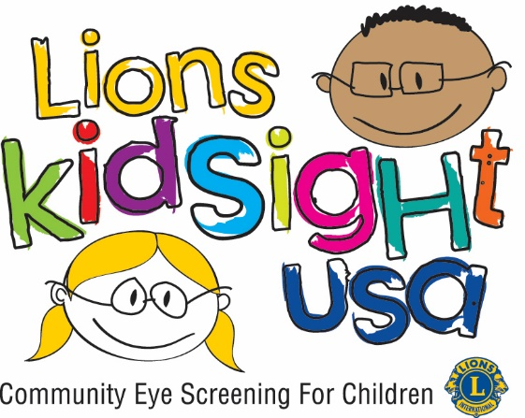

Trouble Shooting

When conducting screenings, the most commonly encountered problems and solutions are:

ALWAYS Switch the printer on first, allow it to boot-up before switching on the camera

- Printer carriage jam
  - This occurs when the printer has been dropped (baggage handler syndrome!)

When this occurs, the printer cartridges are dislodged in the carriage. To fix this, open the printer as though you were going to change a cartridge. You will see/hear the cartridge carriage trying to get to the central position.

With the power off gently slide a plastic ruler over the top of the cartridges and press down to reengage the carriage…you will hear a click to indicate that you have been successful. Turn the printer power on, and lift the lid again, the carriage should centralize; if it doesn’t, simply repeat the process.

- Printer fails to print after a screening.
  - This happens as a result of hitting the “print” key again before the “sent to printer” message appears on the SPOT screen; this effectively pauses the printer.

To remedy this, on the SPOT screener, go to Tools, scroll to printer, you will see san icon that looks like a pencil, select this icon. At the top of the next screen, you will see a pale blue tool bar indicating that printer name xxx is paused. You will see a reset icon, select that, this will clear the error; the top tool bar will then advise that the printer name xxx is ready. X out of that screen to go back to main screen.

- The keyboard does not seem to function properly
  - If you encounter difficulties when typing, you can calibrate the keyboard; go to Tools, navigate to the (2nd?) screen that says “calibrate”. Follow the intuitive instructions that will calibrate the keyboard to the user.

- Time and date are incorrect.
  - Internal clock/calendar are maintained by a small watch battery; as this runs down, the internal clock/calendar will go to a default. To correct both, go to Tools, navigate to time/date and reset to the correct time and date. This exercise will need to be repeated each time the SPOT screener is turned off/on

